1. The very first page i.e. Home Page

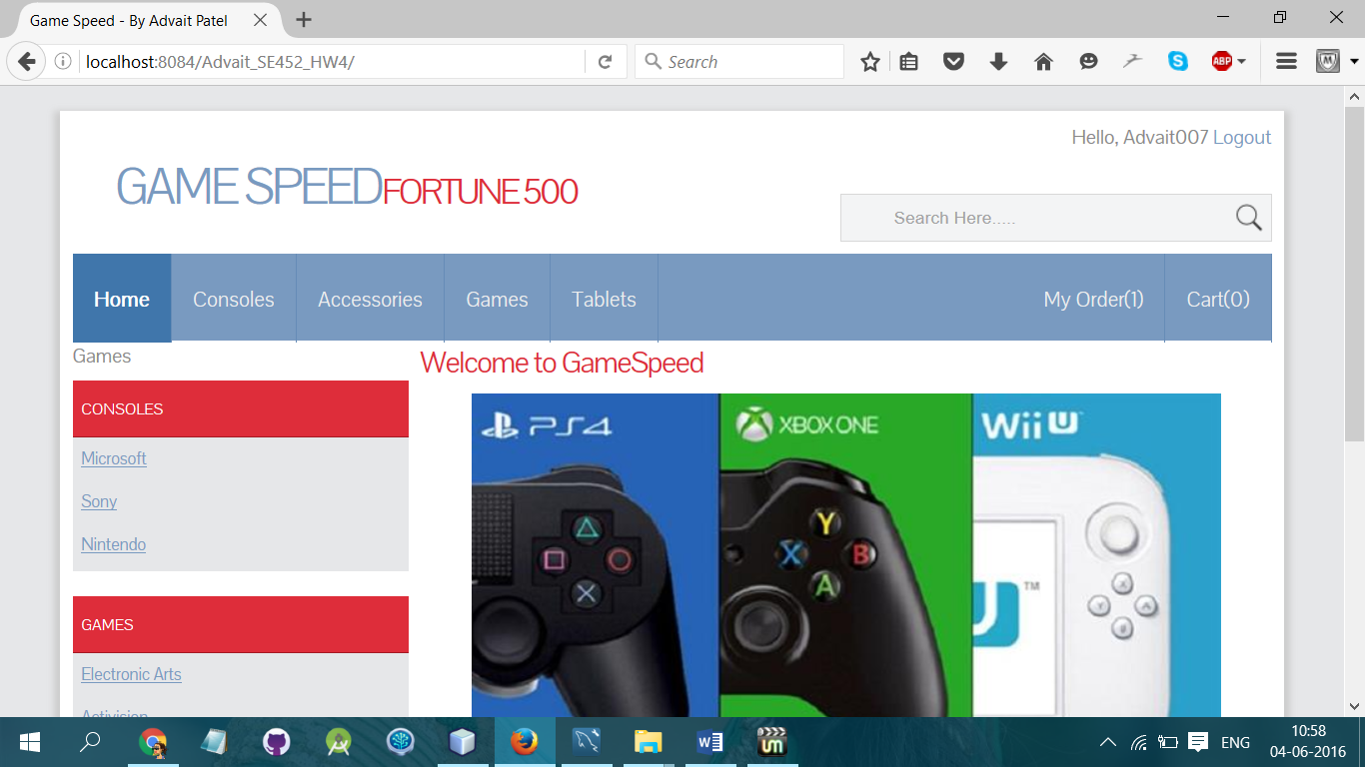

1. While putting some letters on search menu

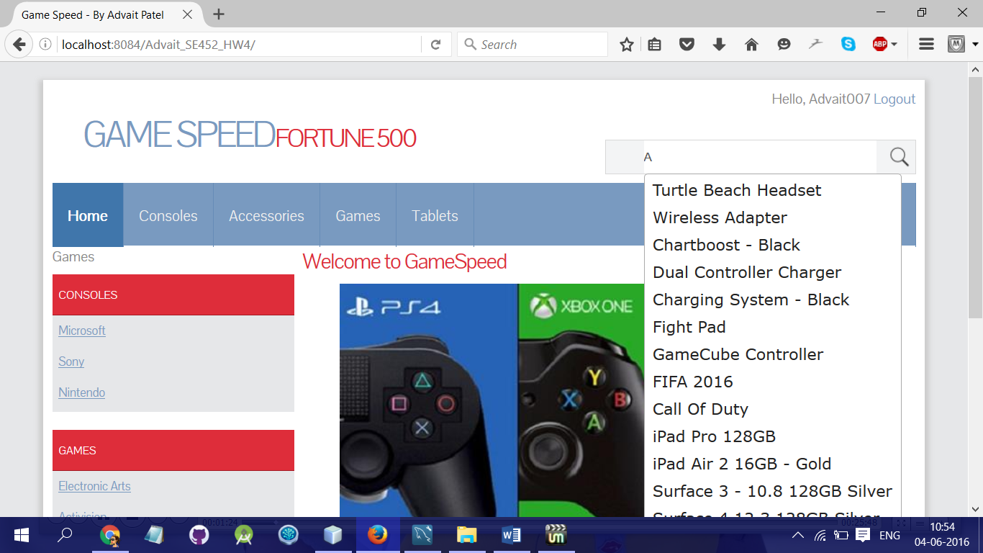

1. Now making keywords as a Hyperlink

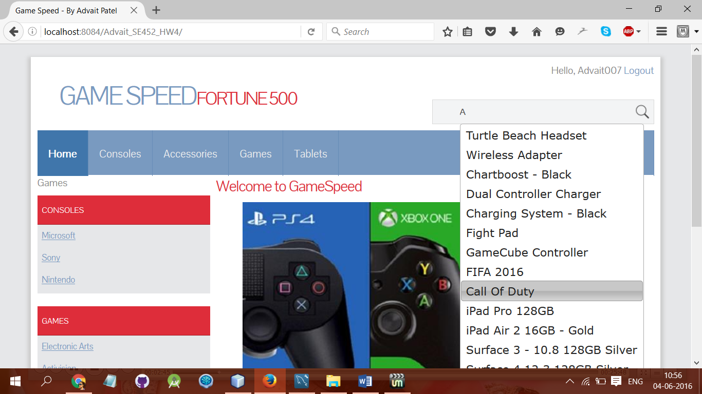

1. Searching for WiiU Product from Search Box

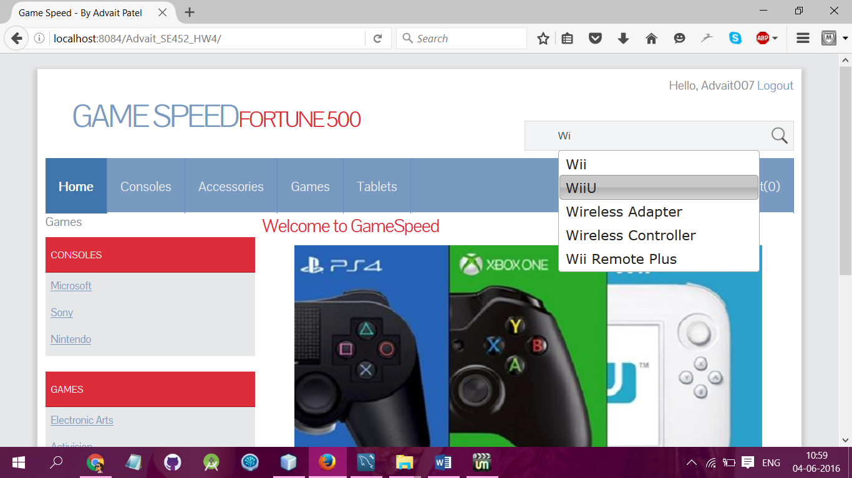

1. Now Click on WiiU Product
2. After Clicking on WiiU Product – Page will be redirected

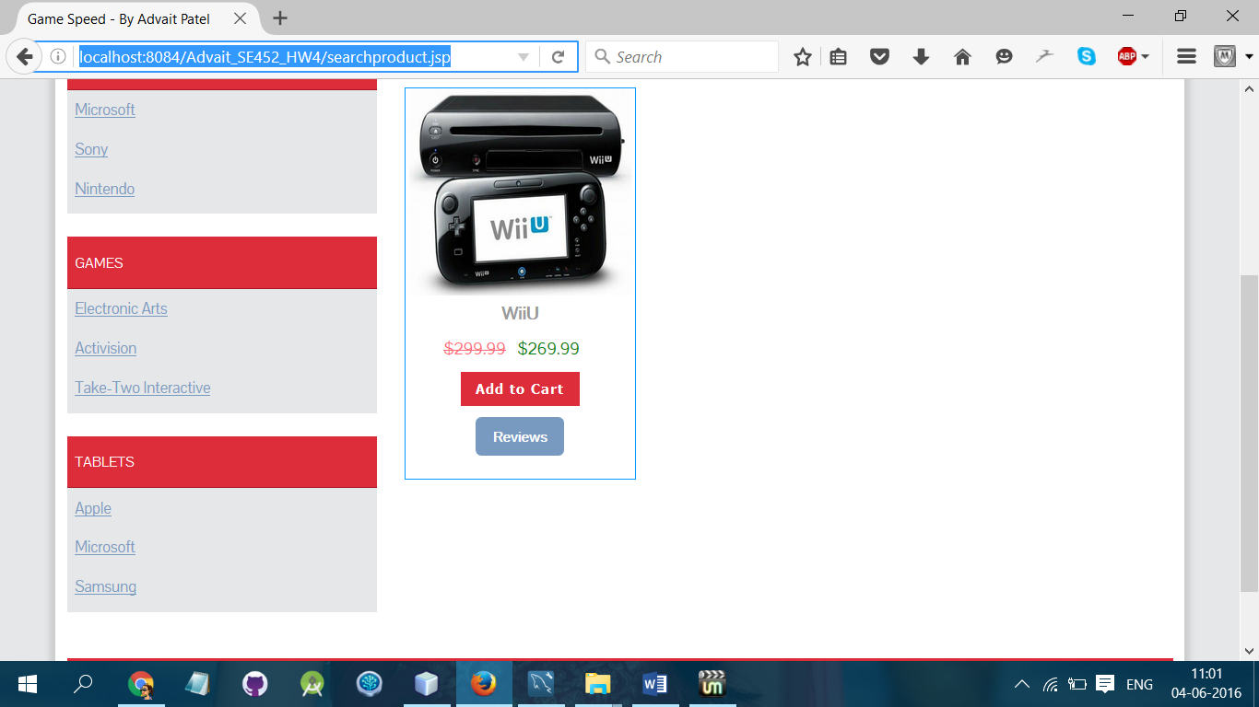

1. Table for Customer Info:

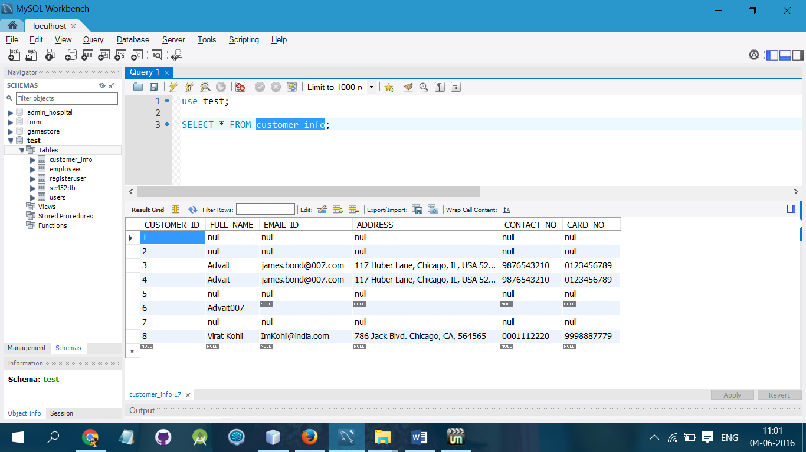

1. Table for Inserting Order/Product Info:

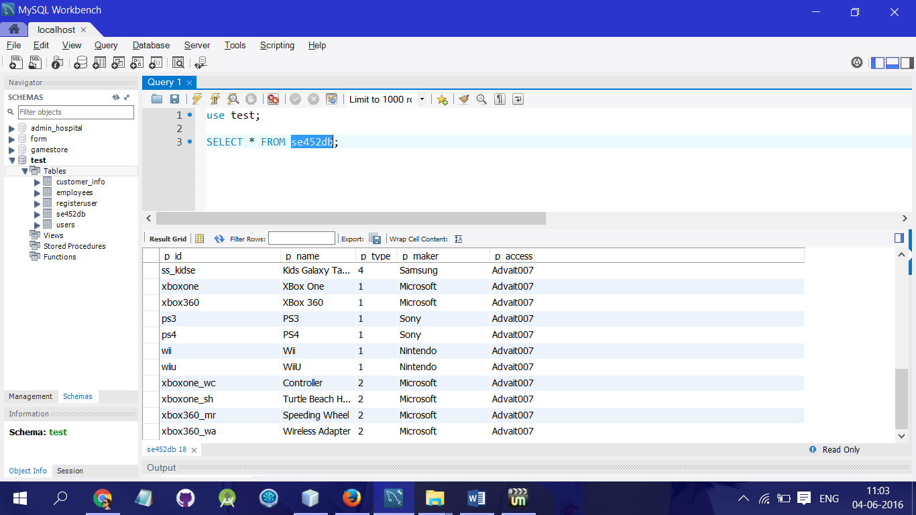

1. Now We are adding WiiU product into the cart:

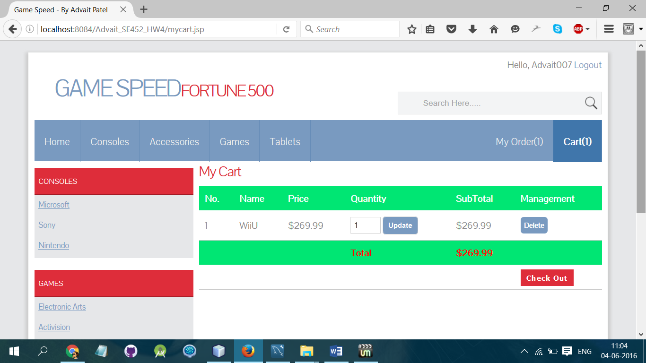

1. It will also have inserted into the database in “se452db” table:

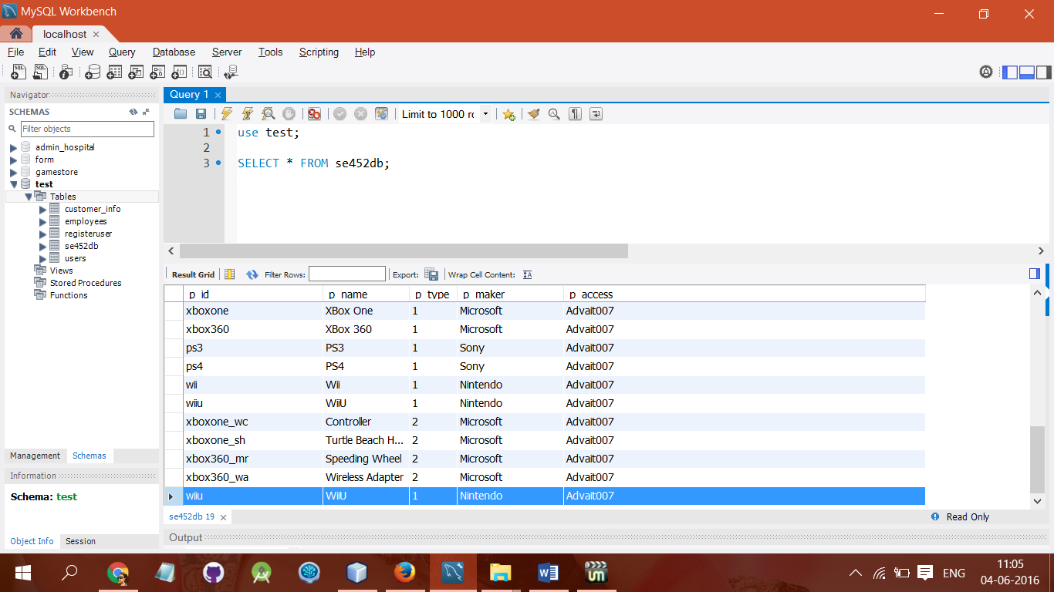

1. Now we will go for checkout action:

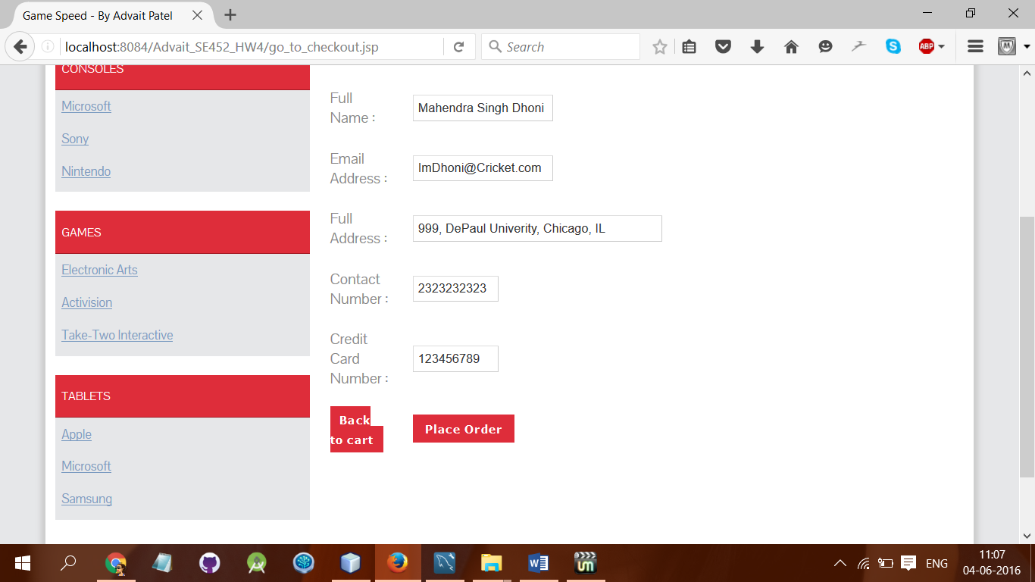

1. After placing an order for WiiU it will inserted in to the database:

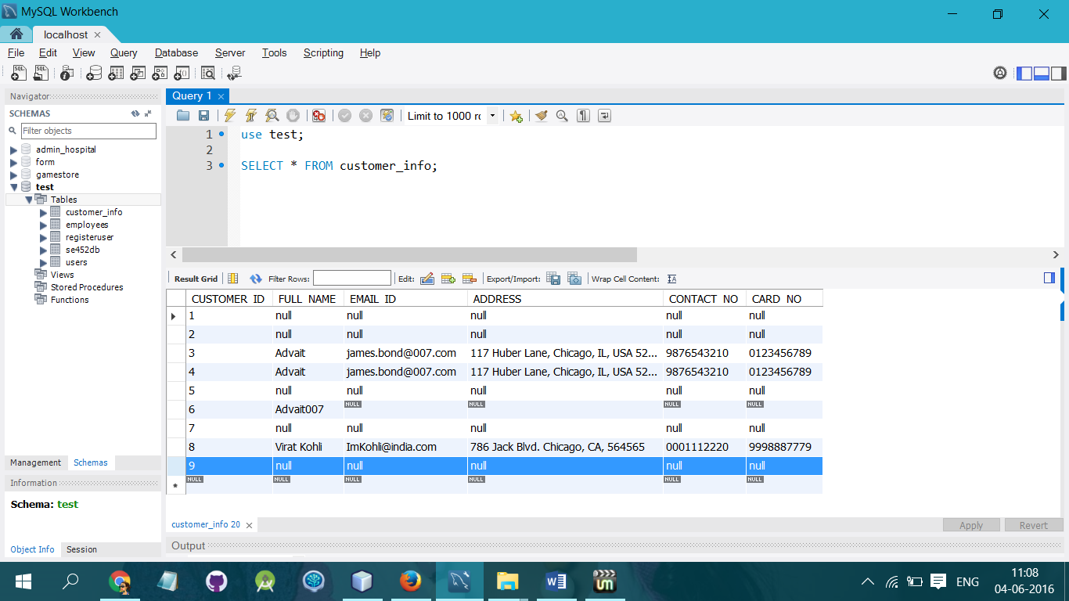

1. The new entry of Mr. Dhoni is successfully inserted in to the table customer_info:

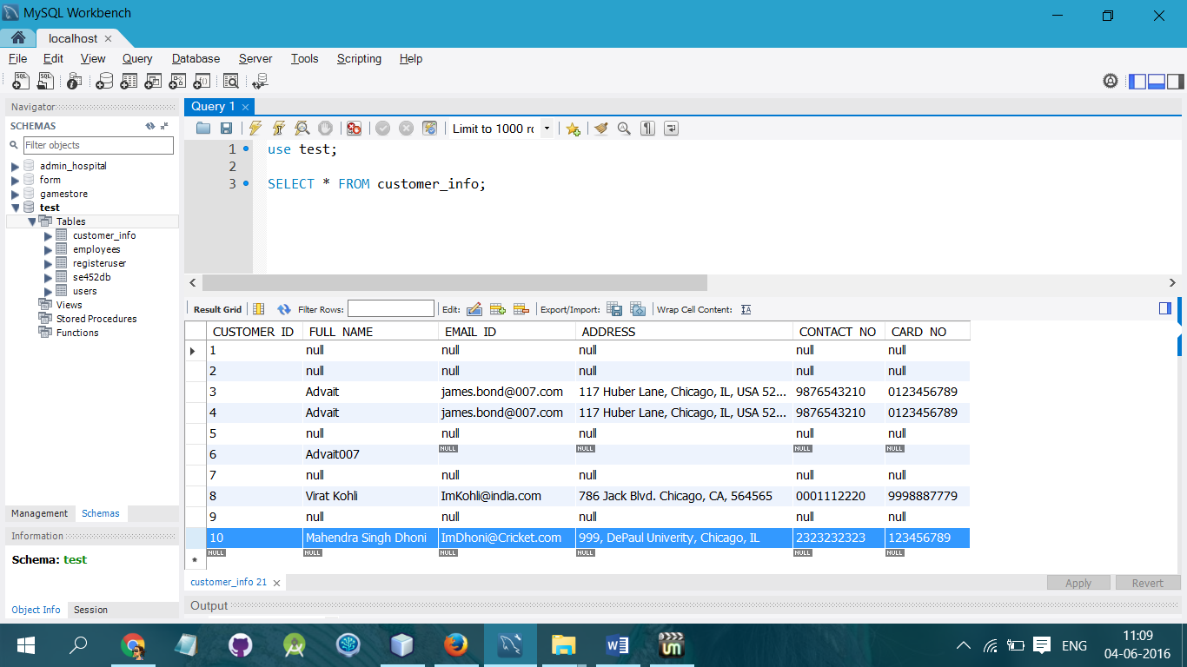

1. Now we will update some information:

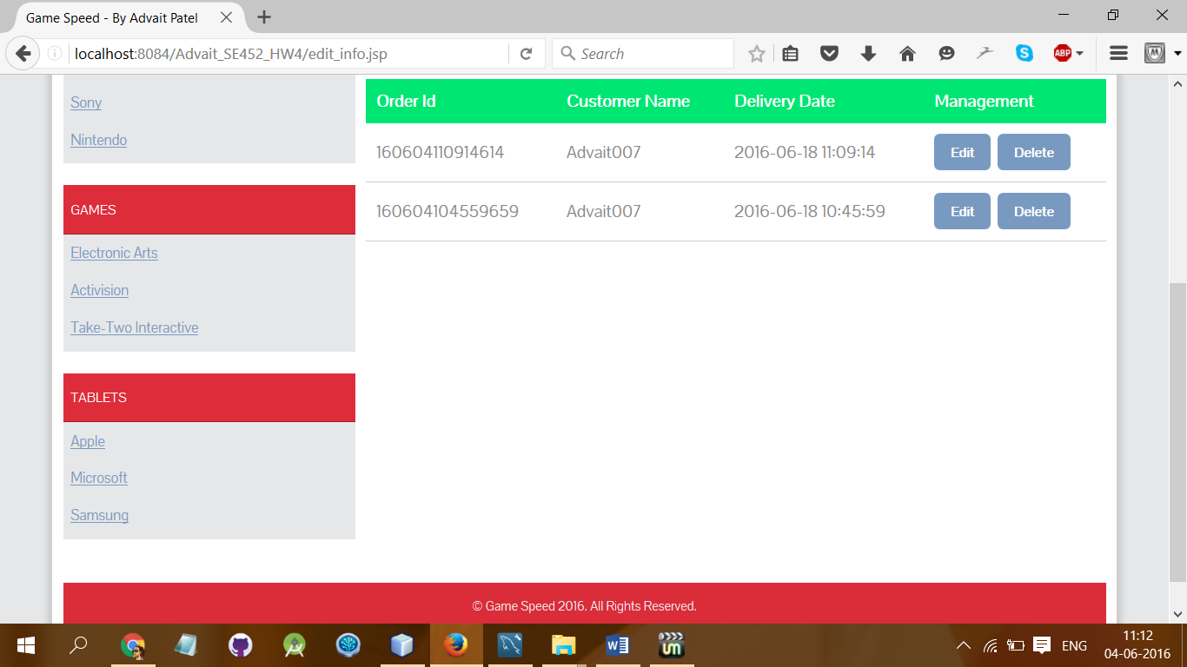

1. Now we will click on Update/Edit Button for action and first of all we will retrieve data from table for that specific user:

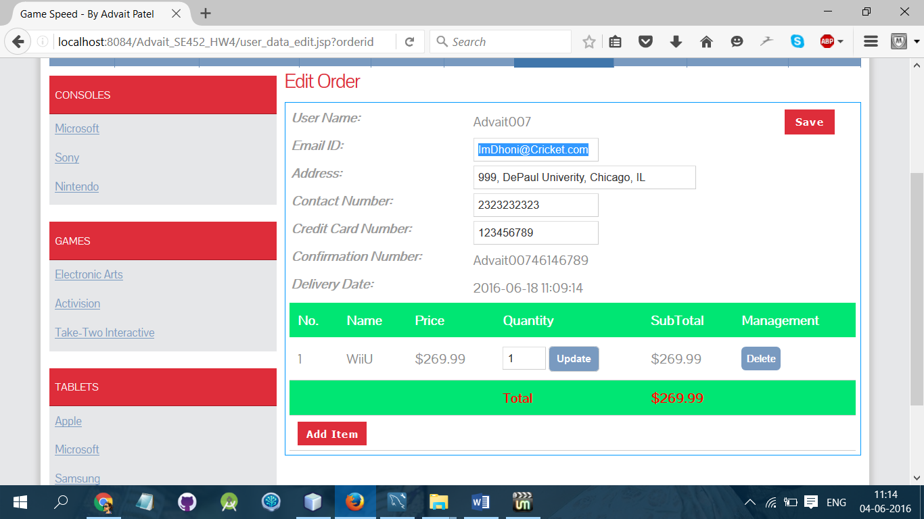

1. Now we will edit some information for Mr. Dhoni

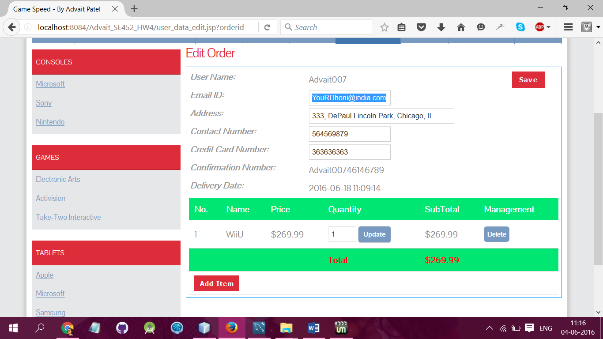

1. After clicking on Save button we can see the update in to the database:

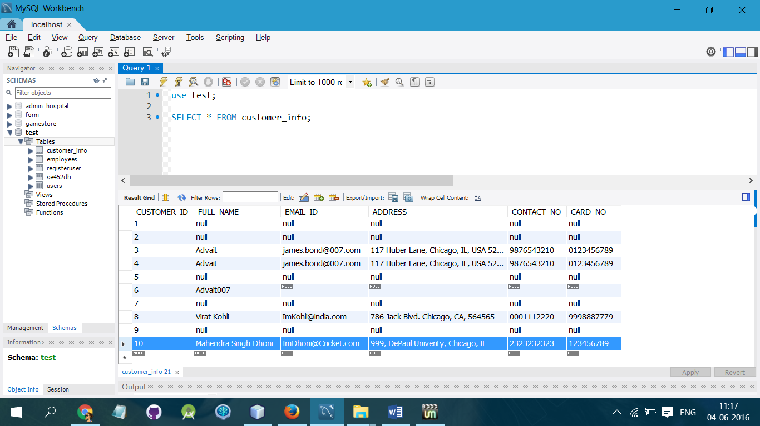

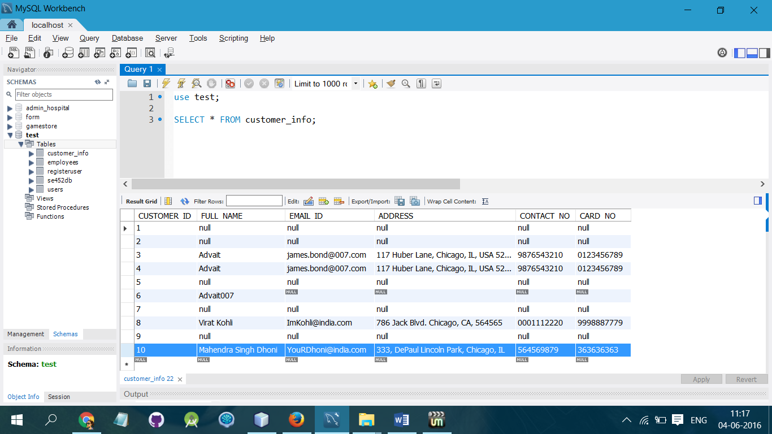

1. Now we will delete an order:

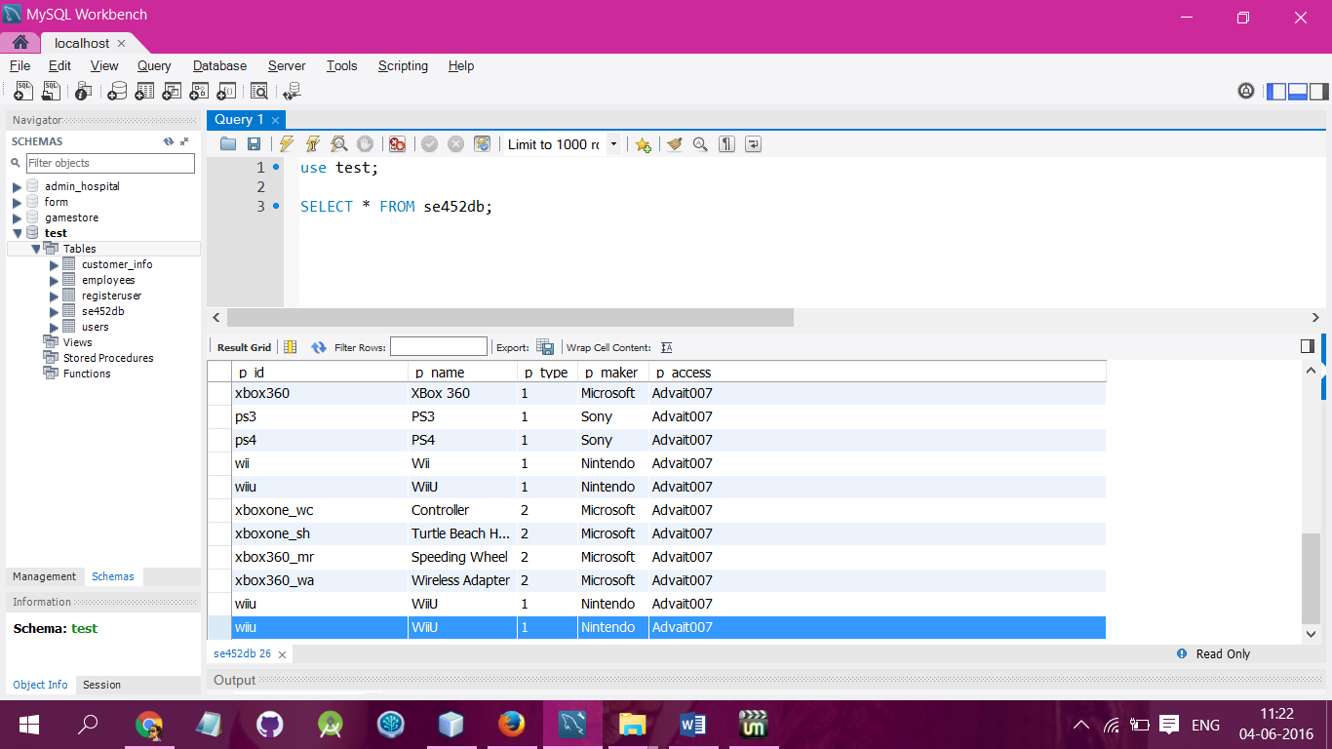

1. We are deleting that last order i.e. WiiU Nintendo.

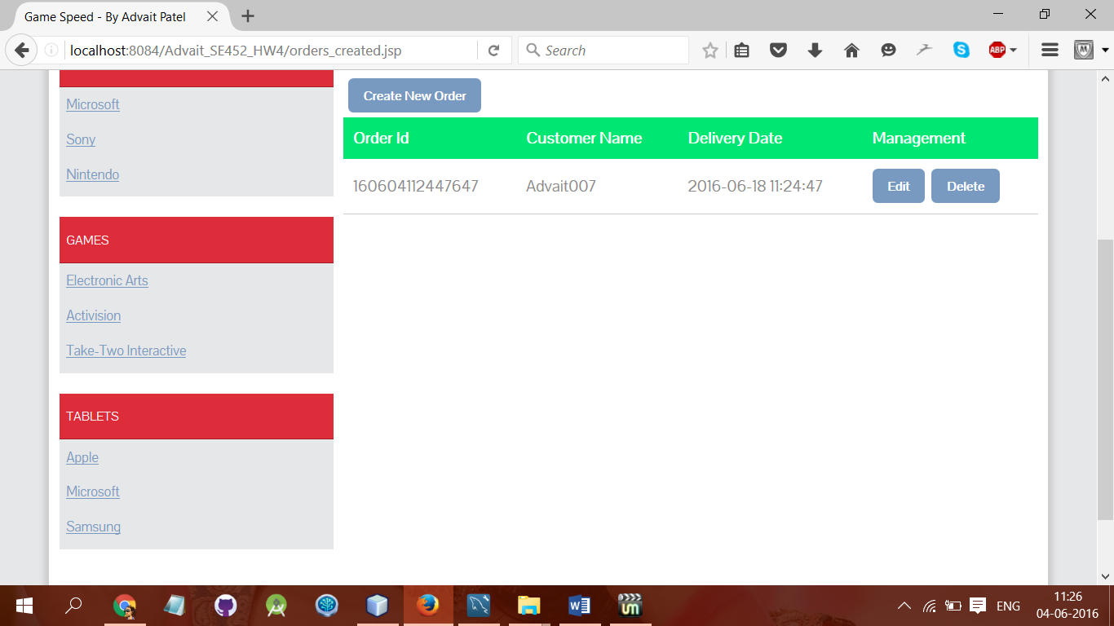

1. Now we will press on Delete Button and the order will be deleted from data:

